📄 Pickelton Backend Project Plan (Java - Spring Boot)
🎯 Goal (MVP)
Build a production-ready backend where:
- Users authenticate
- Clubs exist
- Tournaments are created
- Players register
- Matches are played
- Leaderboard works

🧱 System Modules
auth
user
club
tournament
registration
match
leaderboard
config
security
common

👥 Team Structure
🔥 Rule
- One person controls DB schema (Team Lead)
- Others follow schema + API contract strictly

👨‍💻 Person 1 — Auth + User + Club
📦 Modules
- auth
- user
- club
🗄️ Tables
users
clubs
club_members
🛠️ Tasks
🔐 Auth
- User entity
- Register API
- Login API
- Password hashing (BCrypt)
- JWT token generation
- JWT filter (Spring Security)
👤 User
- Get profile API
- User DTO
🏟️ Club
- Create club
- Join club
- List clubs
- Role system (ADMIN / MEMBER)
📡 APIs
POST /auth/register
POST /auth/login

GET /users/me

POST /clubs
POST /clubs/{id}/join
GET /clubs
✅ Output
- Working authentication system
- Users stored in DB
- Club system functional

👨‍💻 Person 2 — Tournament + Registration
📦 Modules
- tournament
- registration
🗄️ Tables
tournaments
registrations
🛠️ Tasks
🏆 Tournament
- Tournament entity
- Create tournament
- List tournaments
- Get tournament details
- Validate:
  - creator = user
  - optional club_id
📝 Registration
- Register for tournament
- Prevent duplicate registration
- Slot limit validation
- Registration status
📡 APIs
POST /tournaments
GET /tournaments
GET /tournaments/{id}

POST /tournaments/{id}/register
✅ Output
- Tournament system working
- Registration system working
- Slot validation implemented

👨‍💻 Person 3 — Match + Leaderboard
📦 Modules
- match
- leaderboard
🗄️ Tables
matches
🛠️ Tasks
🎾 Match
- Create match
- Assign players
- Update score
- Set winner
- Add round field
📊 Leaderboard
- Compute wins/losses
- Rank players
- Tournament leaderboard API
📡 APIs
POST /matches
PATCH /matches/{id}/score

GET /tournaments/{id}/leaderboard
✅ Output
- Matches working
- Score updates working
- Leaderboard functional

👑 Team Lead Responsibilities (You)
🛠️ Tasks
🧱 Setup
- Create Spring Boot project
- Setup folder structure
- Setup DB connection (Supabase)
- Initialize repo
🗄️ Database
- Define schema
- Maintain consistency
- Approve changes
🔗 Integration
- Merge modules
- Fix API mismatches
- Ensure full flow works
🚀 Deployment
- Deploy backend
- Configure environment variables
- Test production APIs

🔗 Dependency Flow
Auth → User → Club
↓
Tournament → Registration
↓
Match → Leaderboard

📅 Timeline
Week 1 — Foundation
- Auth complete
- DB setup done
- Club APIs ready
Week 2 — Core
- Tournament APIs
- Registration system
Week 3 — Gameplay
- Match APIs
- Leaderboard
Week 4 — Final
- Integration
- Deployment
- Bug fixing

⚙️ Git Workflow
main → stable
dev → integration

feature/auth
feature/tournament
feature/match

⚠️ Rules
- One DB schema owner
- Same naming conventions
- Use DTOs (no direct entity exposure)
- Test APIs daily
- Integrate early

🚨 Risks
- Auth delay blocks everything
- DB mismatch breaks integration
- API mismatch causes failures

🧠 MVP Scope
✅ Build Now
- Auth
- Clubs
- Tournaments
- Registration
- Matches
- Leaderboard
❌ Later
- Payments
- Feed system
- Image uploads
- Analytics

🔥 Final Product Vision
Pickelton =
Auth
+ Clubs
+ Tournaments
+ Matches
+ Leaderboard
Later:
+ Feed
+ Payments
+ Analytics

📄 PICKELTON FRONTEND PLAN (Next.js)
🎯 Goal
Build a scalable web app (Next.js) that:
- connects to your Spring Boot backend
- supports tournaments, matches, clubs
- is structured for team development
- can later extend to mobile (Expo)

🧱 TECH STACK
- Framework → Next.js (App Router)
- Language → TypeScript
- Styling → Tailwind CSS
- API calls → Axios / fetch
- State (basic) → React state (later Zustand if needed)

🧩 PROJECT STRUCTURE (FINAL)
pickelton-web/
├── app/
│ ├── (auth)/
│ │ ├── login/page.tsx
│ │ └── signup/page.tsx
│ ├── dashboard/page.tsx
│ ├── clubs/
│ │ ├── page.tsx
│ │ └── [id]/page.tsx
│ ├── tournaments/
│ │ ├── page.tsx
│ │ ├── create/page.tsx
│ │ └── [id]/page.tsx
│ ├── matches/
│ │ ├── page.tsx
│ │ └── [id]/page.tsx
│ ├── leaderboard/
│ │ └── [id]/page.tsx
│ ├── profile/page.tsx
│ └── layout.tsx
│
├── components/
├── services/
├── hooks/
├── types/
├── utils/
└── styles/

📄 CORE PAGES (MVP)
🔐 Auth
- /login
- /signup

🏠 Dashboard
- /dashboard
- Shows:
  - upcoming tournaments
  - quick actions

🏟️ Clubs
- /clubs
- /clubs/[id]
Features:
- view clubs
- join club

🏆 Tournaments
- /tournaments
- /tournaments/create
- /tournaments/[id]
Features:
- list tournaments
- create tournament
- view details
- register

📝 Registration
👉 inside tournament page

🎾 Matches
- /matches
- /matches/[id]
Features:
- view matches
- update score

📊 Leaderboard
- /leaderboard/[id]

👤 Profile
- /profile

🎨 UI COMPONENTS (REUSE THESE)
From your existing project:
- CourtCard → matches/tournaments
- GroupCard → clubs
- Navigation → layout
👉 Don’t rewrite—reuse and adapt

🔗 API LAYER (IMPORTANT)
Create:
services/api.ts
Example:
import axios from "axios";

export const api = axios.create({
baseURL: "http://localhost:8080",
});

Example API usage:
export const getTournaments = async () => {
const res = await api.get("/tournaments");
return res.data;
};

🔐 AUTH HANDLING
- Store JWT in:
  - localStorage (simple)
- Add interceptor:
api.interceptors.request.use((config) => {
const token = localStorage.getItem("token");
if (token) config.headers.Authorization = `Bearer ${token}`;
return config;
});

👥 TEAM SPLIT (FRONTEND)
👨‍💻 Person 1 — Auth + Layout
- login/signup pages
- navbar
- route protection

👨‍💻 Person 2 — Clubs + Tournaments
- club pages
- tournament pages
- registration UI

👨‍💻 Person 3 — Matches + Leaderboard
- match pages
- score UI
- leaderboard UI

⚙️ DATA FLOW
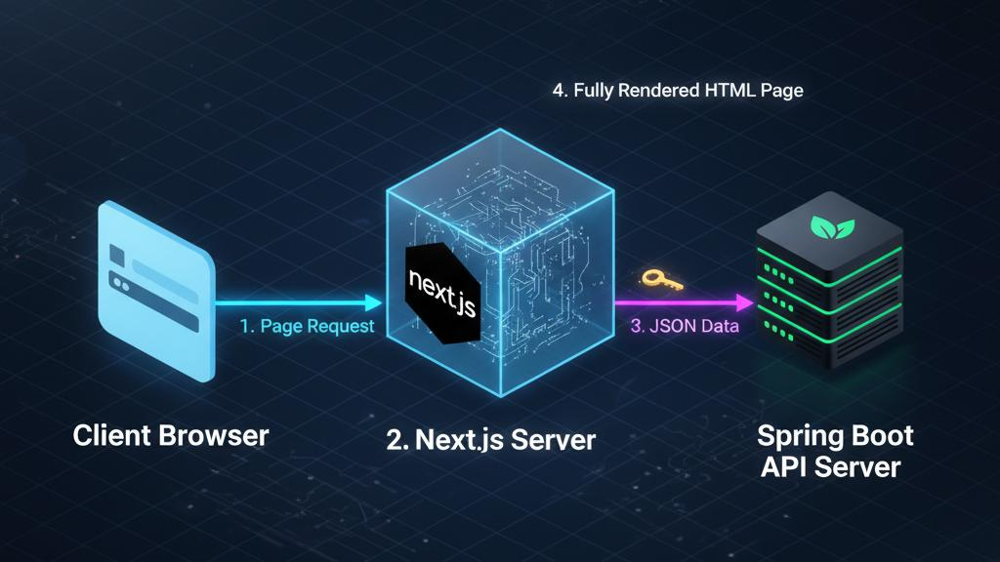
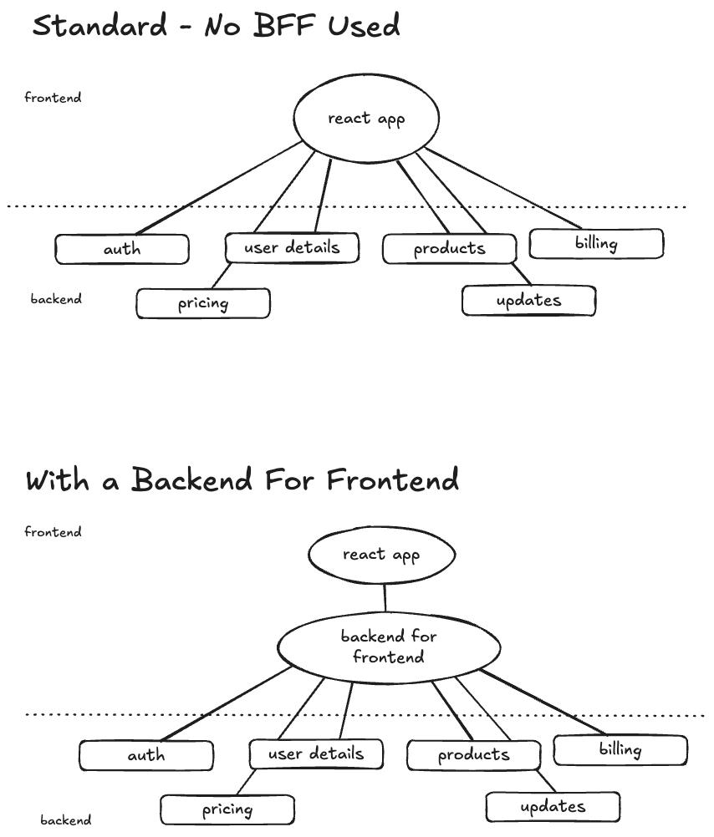
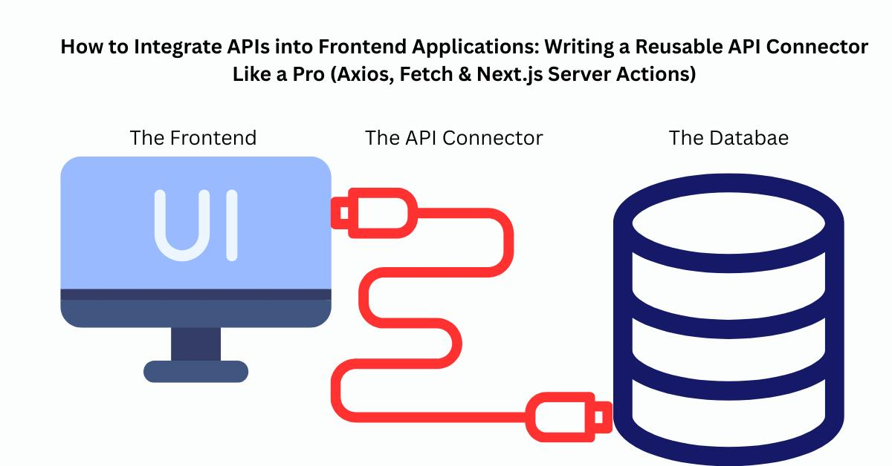
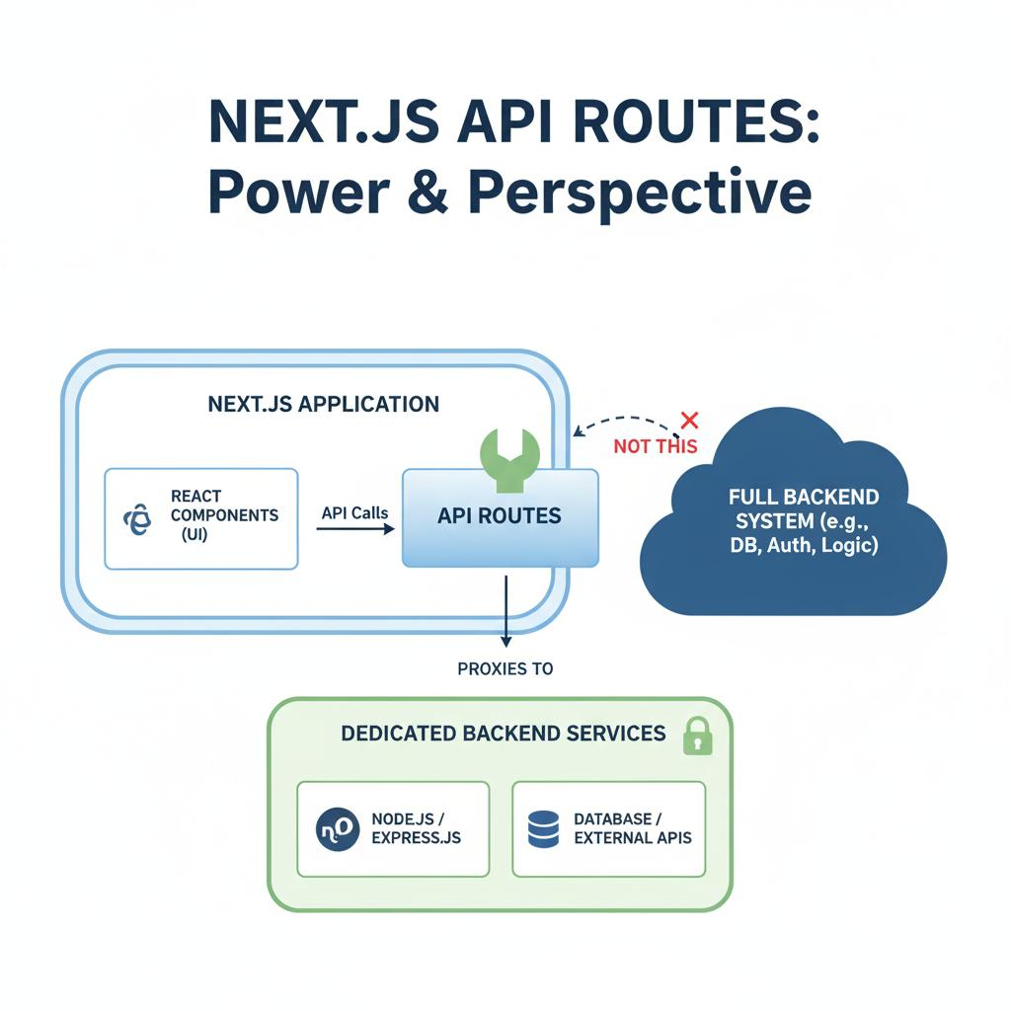
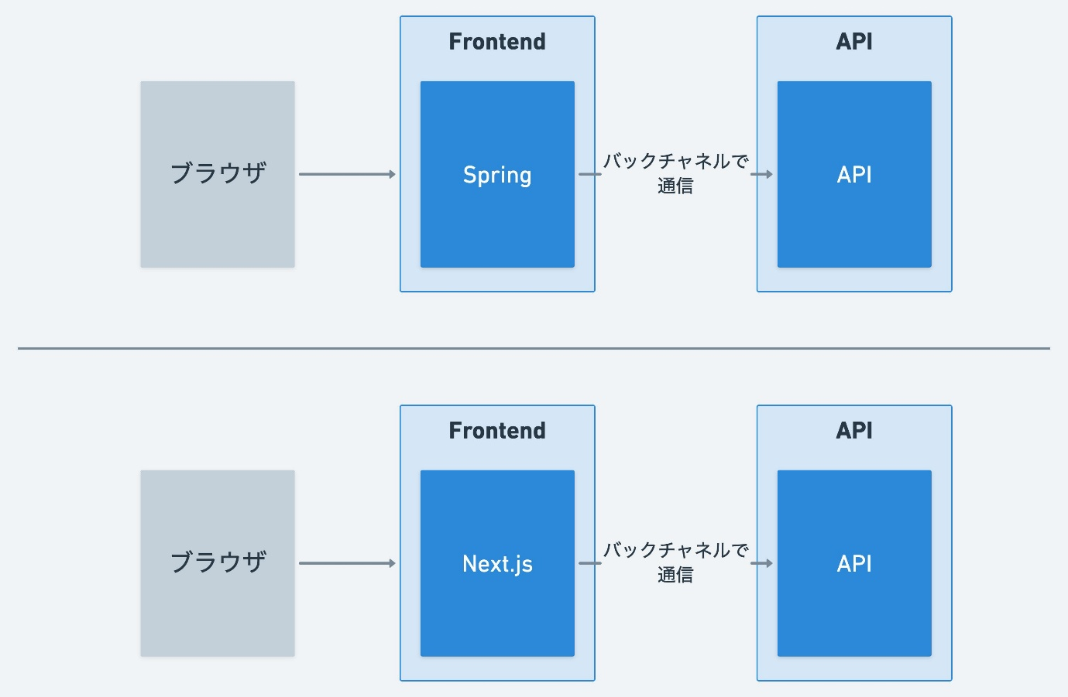
User Action → Next.js UI → API call → Spring Boot → DB → Response → UI update

📅 EXECUTION PLAN
🥇 WEEK 1
- Setup Next.js
- Create structure
- Auth pages
- Navigation

🥈 WEEK 2
- Clubs + tournaments UI
- API integration

🥉 WEEK 3
- Matches + leaderboard
- Full integration

🏁 WEEK 4
- UI polish
- Bug fixing
- Deployment

⚠️ RULES
- No hardcoded data
- Use API layer only
- Keep pages separate from components
- Reusable components only
- Keep UI simple first

🚨 COMMON MISTAKES
- ❌ Mixing logic in components
- ❌ No folder structure
- ❌ No API layer
- ❌ Trying to perfect UI first

🧠 FINAL ARCHITECTURE
Next.js (Frontend)
↓
Spring Boot (Backend)
↓
PostgreSQL (Supabase)

